About
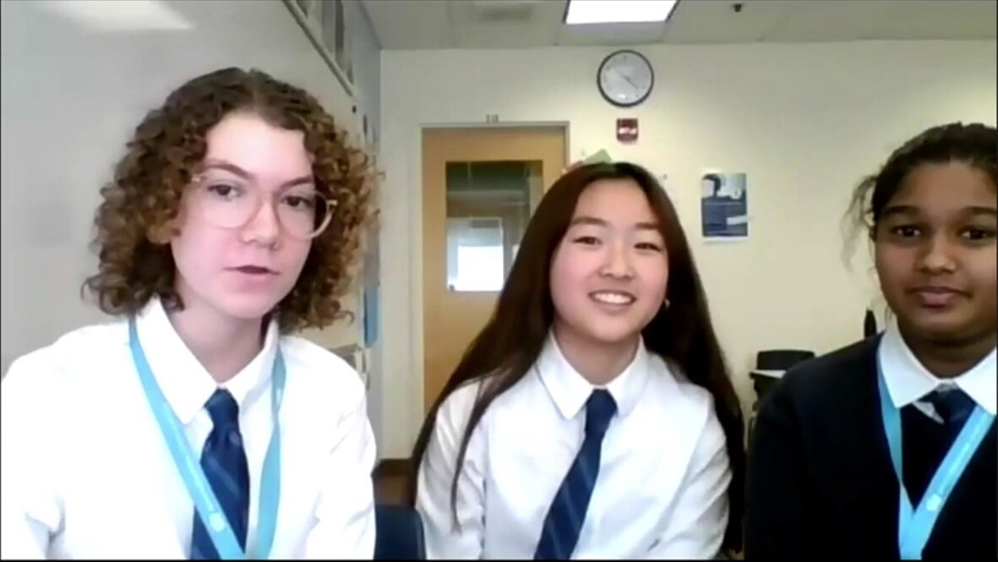
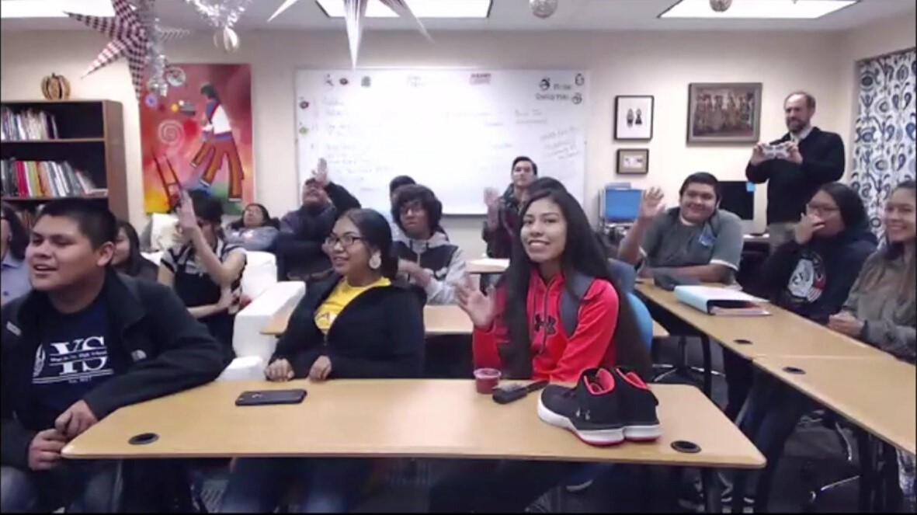
United Planet’s Virtual Chapters allow students throughout the United States to work in collaboration with students from other countries such as Morocco, Iraq, Jordan, Mali, and many more. Diverse global schools work together in small groups, called United Planet Circles, to engage in collaborative, project-based learning over a series of 8 week modules focused on global goals (United Nations Sustainable Development Goals) and cross-cultural sharing. Students collaborate during live sessions, called United Planet Gatherings, as well as asynchronous conversations.
United Planet Chapters
Virtual Exchange Global School Network
i
Vision  To connect all schools through positive interaction and partnership. CNN selected United Planet as one of only ten organizations worldwide, which allows young people to “Be the Change that they wish to see in the world” and the President of Iraq enthusiastically signed on and introduced schools. Other schools in Jordan and Morocco | Ideal for  Virtual Chapters are perfect for any middle school or high school geography, environmental science, creative writing, foreign language, history, social studies, computer science, civics and economics class, International Baccalaureate Program, and more!
have signed on to participate.
"
My students have no opportunities to connect with others who are different from them. United Planet Virtual Exchange helped my students grow and connect with a broader world.
"

Dr. Steven Berbeco, Ed.D.
Superintendent, Hopi Schools
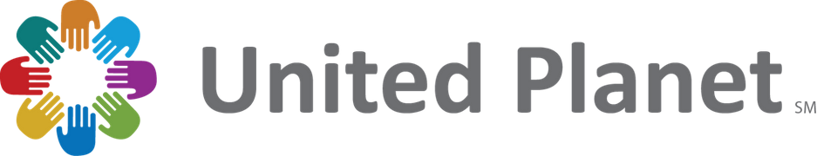
©2020 United Planet. All rights reserved.

Modules
GLOBAL GOALS VOICES OF EARTH
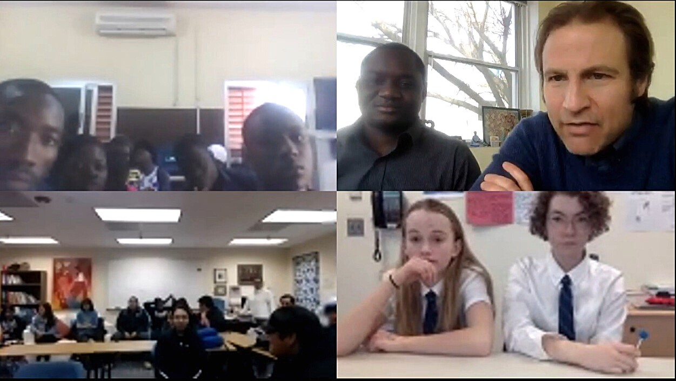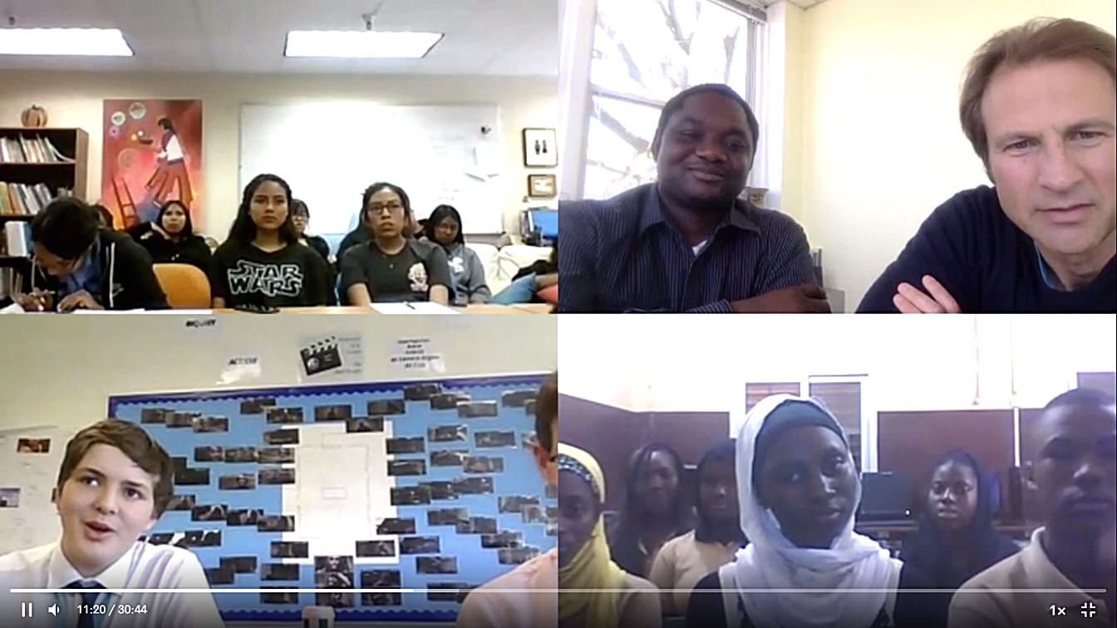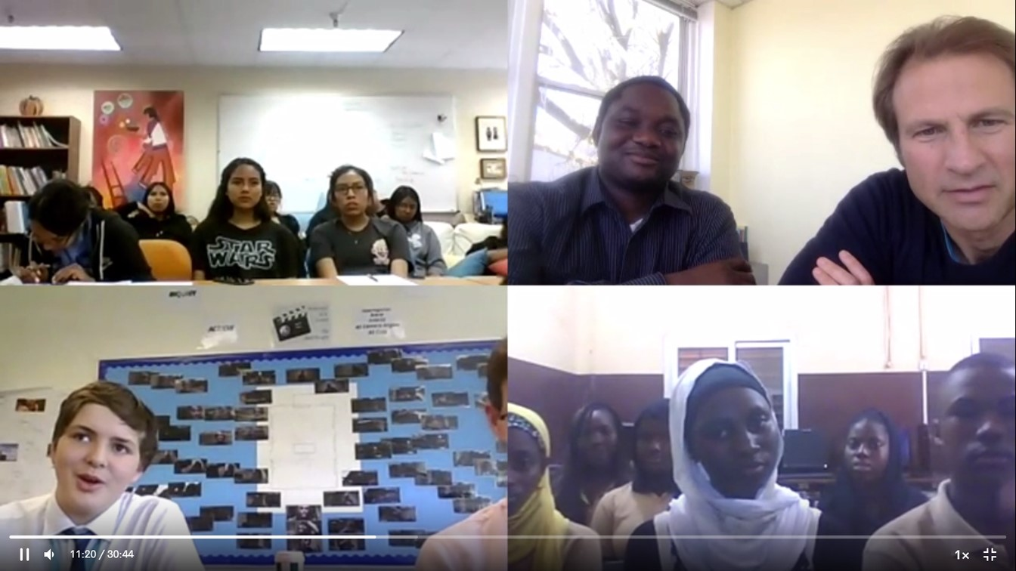
(January - March) (October - December)
Project based on Sustainable Project based on Culture, Development Goals Community, Country, or Land
Critical Thinking
Creativity
Collaboration
Communication
Learning Skills

Information Literacy
Media Literacy
Technology Literacy
Literacy Skills

Flexibility
Leadership
Initiative
Life Skills

Productivity
Social Skills
i

Areas of Impact
Students will develop 21st century academic and career skills as global citizen leaders for success in a rapidly changing, digitally- based, and globally interconnected world, while building a more united planet together.
Case Study  During the global goals module, the British  International School of Boston, Hopi Junior/Senior  High School, and the Youchaou School of Bamako, Mali worked together as a United Planet Circle to look at local challenges related to United Nations Sustainable Development Goal-15, Life on Land. They assessed local challenges, came up with solutions, and implemented those solutions. | Technology Savvy  Schools will be guided through every step of the program by their United Planet facilitator. Participants will be connected with two to four other schools around the world using Zoom Video Conferencing and Moodle collaboration tools. Students will build relationships and learn from other students in Africa, Middle East, Europe, and beyond.
256 Marginal Street, Boston MA 02128 USA | 617.874.8041 | unitedplanet.org
©2020 United Planet. All rights reserved.

